
Department of Computer Science

University of Gujrat

IELTS Preparation Web

(Proposal)

Submitted By:

M.Abdul Wahab | Roll No: 21014119-006
M.Ahmad Butt | Roll No: 21014119-047
M.Furqan Chemma | Roll No: 21014119-060

Supervised By:
Mr.Abo Bakar Aslam

DECLARATION

I certify that project title IELTS PREPARATION WEB is under my supervision with students of Bachelor of Science (Computer Science) M.ABDUL WAHAB - 21014119-006, M.AHAMD BUTT - 21014119-047, M.FURQAN CHEMMA - 21014119-060, Faculty of Computing & Information Technology, University of Gujrat, Pakistan, worked under my supervision.

Lecturer:
Mr.Abo Bakar Aslam
Department of Computer Science
Faculty of Computing & Information Technology
University of Gujrat, Punjab, Pakistan.
Email: muhammad.abobakar@uog.edu.pk

Dated: 25-09-2024

Table of Contents
Final Year Project Proposal 4
1.1. Introduction 4
1.2. Project Title: 4
1.3. Project Overview statement: 4
1.4. Project Goals & Objectives: 6
1.5. High-level system components: 6
1.6. List of optional functional units: 6
1.7. Exclusions: 7
1.8. Application Architecture: 7
1.9. Gantt chart: 8
1.10. Hardware and Software Specification: 8
1.11. Tools and technologies used with reasoning: 8

Final Year Project Proposal

1.1 Introduction

This proposal outlines the development of an IELTS preparation website aimed at providing students with an intuitive and interactive platform to enhance their English language skills. The website will offer a variety of resources, including practice tests, interactive exercises, and personalized feedback. Leveraging modern frontend and backend technologies along with Natural Language Processing (NLP), the platform will deliver an intelligent and scalable solution for IELTS aspirants.

1.2. Project Title:

IELTS Preparation Platform using React, Python Backend Frameworks, and NLP.

1.3. Project Overview statement:

The proposed project aims to develop a comprehensive IELTS preparation platform that supports multiple user interactions and efficiently handles large data volumes. The frontend will be developed using React for a dynamic and user-friendly interface, while the backend will utilize Python frameworks such as FastAPI and Flask or Django for high-performance API management and data handling. The platform will incorporate MySQL databases or mongodb for secure and scalable data storage. Additionally, NLP techniques will be employed to provide intelligent feedback on writing and speaking tasks, enhancing the overall user learning experience.

Project Overview Statement Template
Project Title: IELTS PREPARATION WEB
Project Manager: Mr.Abo Bakar Aslam
Project Members:
Name | Registration # | Email Address | Signature
M.ABDUL WAHAB | 21014119-006 | 21014119-006@uog.edu.pk
M.AHMAD BUTT | 21014119-047 | 21014119-047@uog.edu.pk
M.FURQAN CHEEMA | 21014119-060 | 21014119-060@uog.edu.pk

Project Goal: To build an intelligent web application that aids students in their IELTS preparation using modern web technologies and NLP.

Objectives:
Sr.#
1 | User-friendly design
2 | Ensure smooth deployment
3 | Core Ai Architecture
4 | Secure and scalable database architecture
5 | Timely deployment
6 | Performance

Project Success criteria:

User Satisfaction: Positive user feedback regarding ease of use and interface.
Performance: The website meets performance and scalability goals.
Feature Completeness: Completion of the mobile application with all functional modules working as expected.
Support: Support for all browsing platforms.

Assumptions, Risks and Obstacles:

Assumptions: Stable scope, available resources, reliable third-party services.
Risks: Scope creep, technical issues, security threats, performance problems.
Obstacles: Resource constraints, compatibility, low user adoption, and regulatory changes.

Organization Address (if any):

Type of project: Research Development
Target End users:
Urban adults aged 14 and above, across all genders.
Development Technology: Object Oriented Structured
Platform: Web based Distributed
Desktop based Setup Configurations
Other_____________________
Approved By: Mr.Abo Bakar Aslam
Date: 25-09-2024

1.4. Project Goals & Objectives:

• Goal:
To build an intelligent web application that aids students in their IELTS preparation using modern web technologies and NLP.

• Objectives:

- Develop a user-friendly frontend using React to enhance user interaction and engagement.
- Implement a robust backend using Python frameworks (FastAPI and Flask or Django) to manage data and user requests.
- Design a secure and scalable database architecture using MySQL or mongodb to store and manage user data.
- Integrate NLP models to provide real-time feedback on writing and speaking tasks.
- Implement features like practice tests, progress tracking, and personalized recommendations.

1.5. High-level system components:

1. User Interface (Frontend)
- React: A dynamic and responsive user interface built with React, enabling smooth navigation and interaction for users.
- Component-Based Architecture: Separate components for features such as user login, exam practice, evaluation, learning materials, and progress tracking.
- UI/UX Frameworks: Usage of CSS libraries like TailwindCSS, Bootstrap, or Material-UI to ensure a consistent and user-friendly design.

2. Backend Services (API Layer)
- Python Frameworks (FastAPI, Flask, or Django):
  - FastAPI for high-performance, asynchronous API handling.
  - Flask/Django for routing, middleware, and request/response management.
- Authentication & Authorization: Secure user management using token-based authentication (e.g., JWT) for login, registration, and role-based access control.

3. Database Layer
- Relational Database (MySQL): For handling structured data such as user profiles, exam results, and progress tracking.
- NoSQL Database (MongoDB): To store unstructured data like NLP feedback, user queries, and large datasets related to study materials.
- Database Communication Layer: ORM (e.g., SQLAlchemy for MySQL or PyMongo for MongoDB) to interact with databases efficiently.

4. Natural Language Processing (NLP) Module
- Text Analysis (Writing Tasks):
  - Leveraging pre-trained models (e.g., transformers, spaCy) to evaluate writing tasks based on grammar, structure, coherence, etc.
- Speech Recognition & Analysis (Speaking Tasks):
  - Using NLP techniques for evaluating pronunciation, fluency, and sentence structure through speech-to-text conversions.
- Feedback System: Provide users with meaningful, automated feedback and suggestions for improvement.

5. Testing and Evaluation Engine
- Customizable Practice Tests:
  - Different sections for Listening, Speaking, Reading, and Writing.
- Automated Scoring: Algorithms for auto-grading the objective sections (Listening, Reading) and NLP-based feedback for Writing and Speaking.
- Result Tracking & Analysis: Store and analyze user performance to provide insights and progress tracking.

6. Content Management System (CMS)
- Learning Material: A management system to upload and organize learning materials such as PDF, slides, video lectures.
- Dynamic Updates: Admins can add or remove study materials based on user needs or content updates.

7. File Storage & Media Handling
- File Handling (PDFs, Slides, and Lectures): Efficient file management for downloadable resources (e.g., using AWS S3 or similar cloud services for file storage).
- Video & Audio Streaming: Properly handled storage and streaming of recorded lectures or speaking task evaluations.

8. Notification System
- Email/Push Notifications: Keeping users updated on new materials, practice test results, and platform updates.
- Event-Driven Notifications: Real-time notifications for tests and feedback submissions.

9. Admin & Reporting Panel
- Admin Dashboard: Manage users, content, and monitor platform activity.
- Reporting: Detailed reporting tools to track user activity, success rates, and system performance.

10. Security Layer
- Data Encryption: Secure sensitive user data through encryption techniques.
- Role-Based Access: Different access levels for users (students, teachers, admins) to manage permissions.

11. API Gateway
- API Management: Centralized routing and management for API requests across different microservices for scalability and maintainability.

1.6. List of optional functional units:

- Integration with external resources for additional study materials.
- Advanced NLP features for grammar and syntax checking functional requirement.

1.7. Exclusions:

The project will not include features like offline access and integration with external payment gateways.

1.8. Application Architecture:

The system will be based on three-tier architecture:
- Presentation Layer: React-based frontend for interacting with users.
- Logic Layer: Python backend using FastAPI and Flask to handle business logic and data processing, integrated with an NLP engine for advanced language processing.
- Data Layer: MySQL or mongodb database for storing user profiles, test data, and other resources.
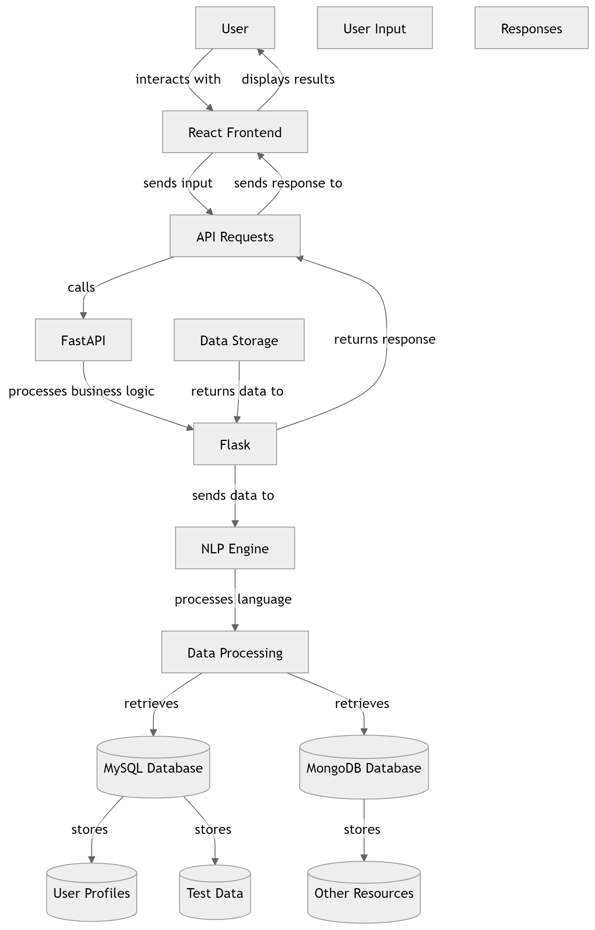
Diagram:

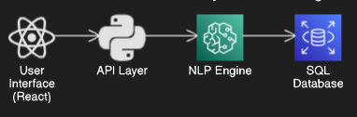

1.9. Gantt chart:
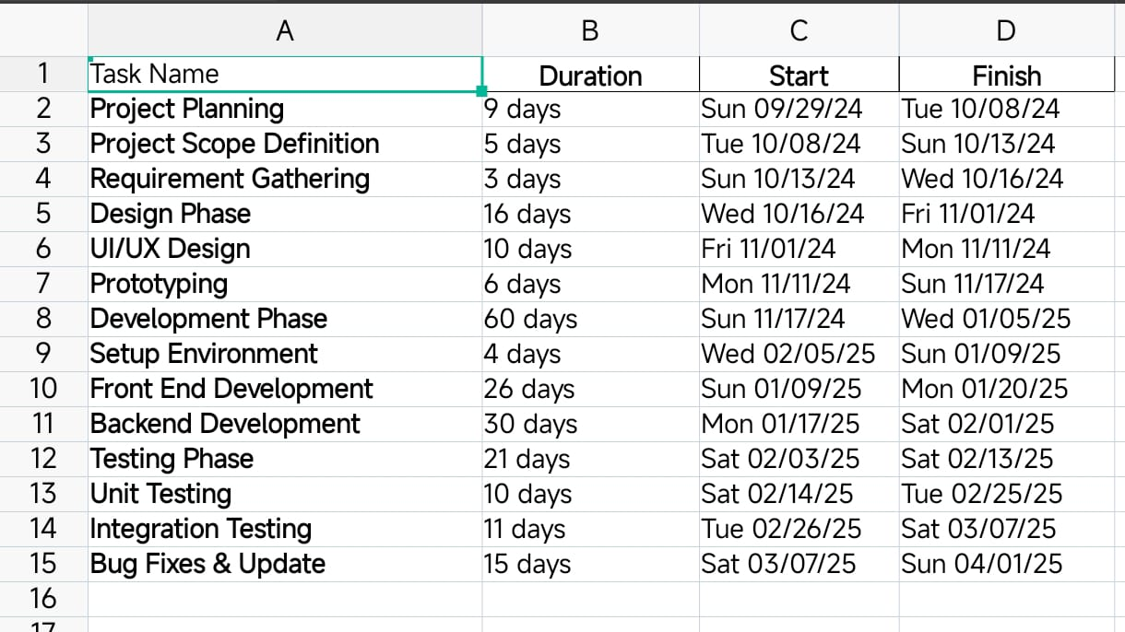

Gantt chart:
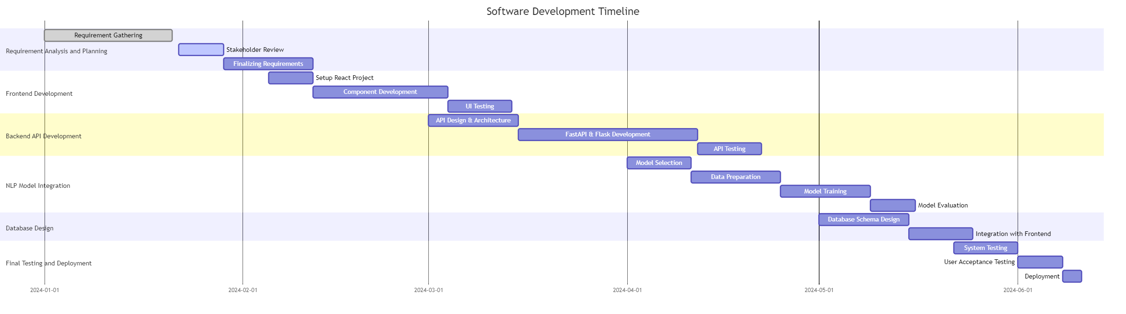

1.10. Hardware and Software Specification:

- • Developer Workstations:
  - Processor: Intel Core i5 or AMD Ryzen 5
  - RAM: 8 GB (16 GB recommended)
  - Storage: 256 GB SSD (512 GB recommended)
  - Graphics: Integrated or dedicated (e.g., NVIDIA GTX)
  - Display: Full HD or higher
- Testing Devices:
  - Smartphones/Laptops/PC:
    - Processor: Qualcomm Snapdragon 6xx series or better/ Dual Core Intel Pentium (Xeon) family or higher recommended/Apple A8 or better.
    - RAM: 4 GB (minimum)/4 GB RAM or more recommended for database or combined web /database server 2 GB RAM or more recommended for web server
    - Storage: 64 GB (minimum)/40 GB or more recommended (non-system drive preferred)
    - Screen Size: 5.5 to 6.7 inches/12 to 16 inches
Software:
- Development Environment:
  - Code Editor: VS Code, Figma
  - Libraries/Frameworks: React, Html, CSS, JavaScript
- Backend Environment:
  - Framework: Python, FastAPI, Flask or Django
  - Database: MySQL or mongodb
- Deployment Tools:
Visual studio Code, GitHub, Docker (for containerization).
- Testing Tools:
  - Manual Testing: Android Devices, Laptops, Desktops

- Frontend: React, HTML, CSS, JavaScript.
- Backend: Python, FastAPI, Flask or Django.
- NLP Libraries: NLTK, SpaCy.
- Database: SQL or mongodb.
- Tools: Visual Studio Code, GitHub, Docker (for containerization).

1.11. Tools and technologies used with reasoning:

• React: For creating a dynamic and interactive user interface.
• FastAPI: For its high performance and easy-to-use API management capabilities.
• Flask or Django: For handling additional API logic and integration needs.
• NLP Libraries (NLTK, SpaCy): To provide intelligent feedback on user responses in the writing and speaking modules.
• Database: Ensures efficient data management and retrieval.
• Docker: To containerize the application, making it easy to deploy and manage across various environments.

